Heavy Weight # 4

**Series #1 w/o strip ; Series #2 w/ strip**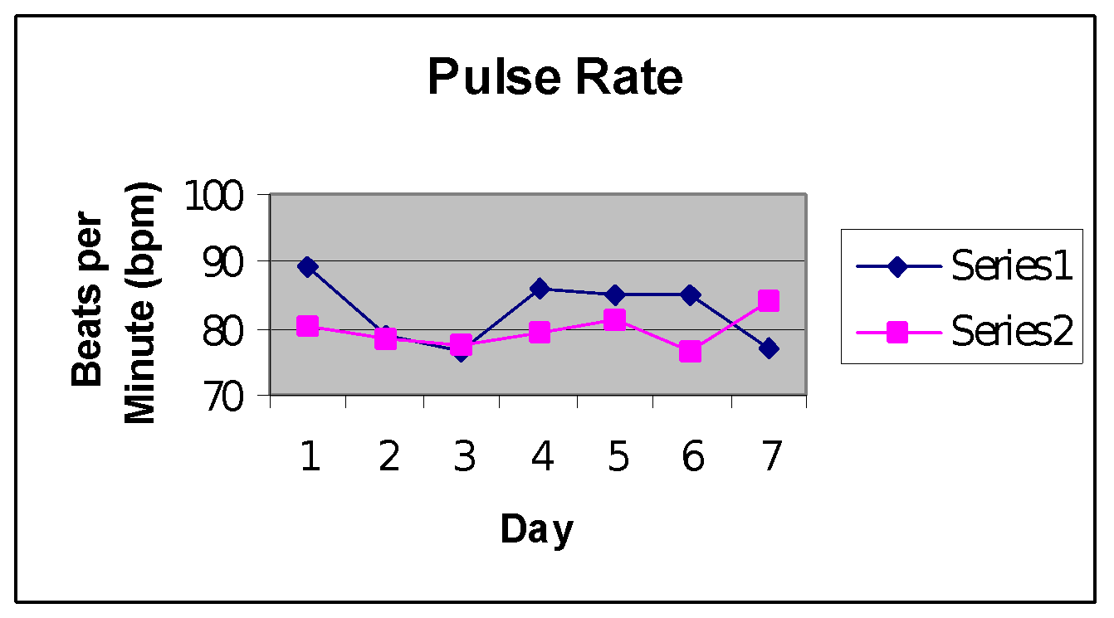

Series #1 mean: 82.519 bpm; Series #2 mean: 79.6337 bpm

The Series #2 mean has a .063 probability of occurring by chance when compared to the Series #1 mean. This gives strong evidence that the nasal strip decreased the subject’s pulse rate.

Series#1 mean: 674.41 ml; Series #2 mean: 692.7188 ml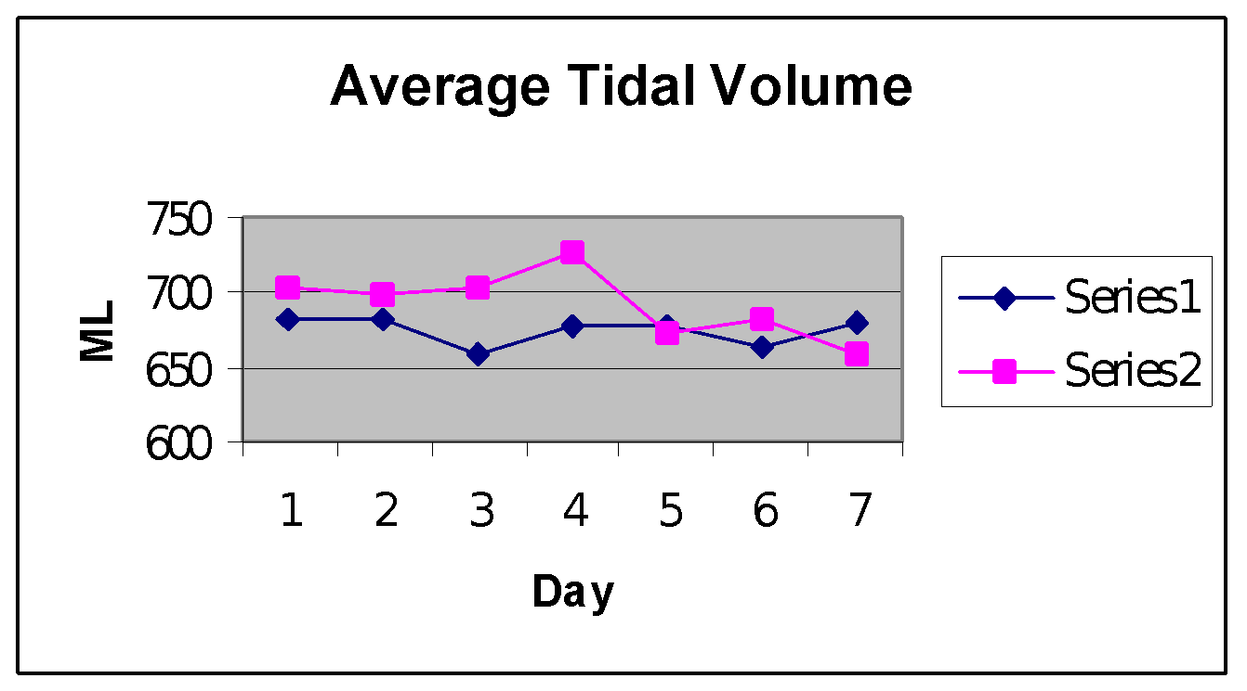

The Series #2 mean has a .0483 probability of occurring by chance when compared to the Series #1 mean. This shows strong evidence that the nasal strip increased the subject’s tidal volume.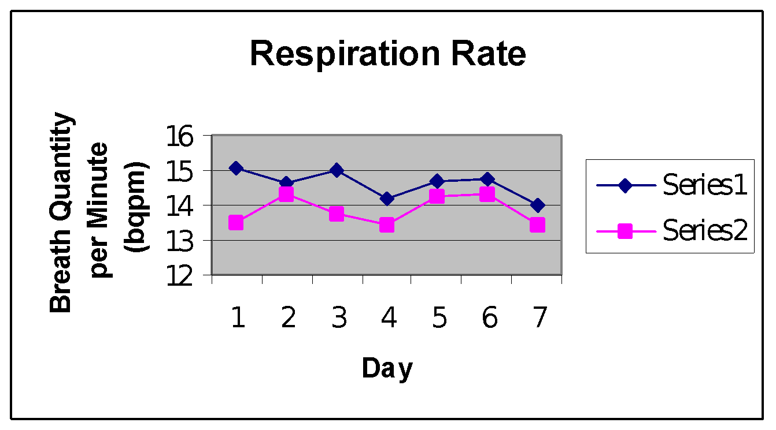

Series #1 mean: 14.849 bqpm; Series #2 mean: 13.8574 bqpm

The Series #2 mean has less than a .01 probability of occurring by chance when compared to the Series #1 mean. This shows strong evidence that the nasal strip decreased the subject’s respiratory rate.

Series #1 mean: 300,429.42 ml; Series #2 mean: 287,978.45ml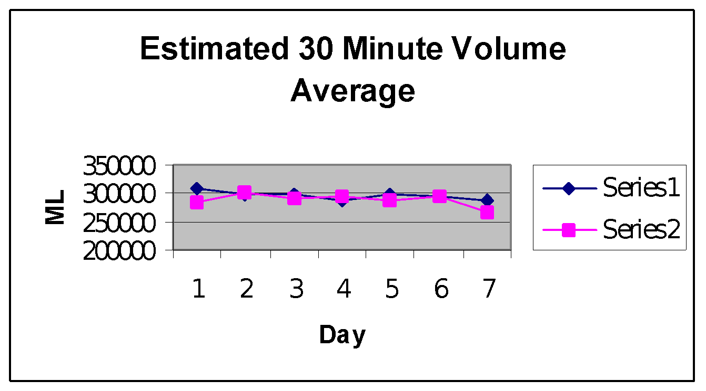

The Series #2 mean has a .38 probability of occurring by chance when compared to the Series #1 mean. This shows weak evidence that the nasal strip either increased or decreased the subject’s 30 minute volume.